**Forestview SafeZone© Calculator Application**

Developed by Chinmay Deore

**Overview:**

This basic integer calculating program uses python to add, subtract, divide, and multiply any value of rational numbers from 0, 1, 2, 3, 4, 5, 6, 7, 8, 9. The user is also provided buttons which insert decimal points within the numbers, solve the expression, and clear any inputs or outputs. This program displays a text entry box which allows the user to manually type in values and characters as an expression or click the buttons to make a calculation with a very sleek and simple user interface and design.

**Application Systems:**

* Python3
* Tkinter Graphical UI
* Name: calc.py (Executable via PyInstaller)
  + Version: 1.0
  + Image: blucalc.ico
  + Modules: No additional programs required

**Compliance:**

* User input will be filtered
* User must comply with the user agreement as a condition to the downloading of the application
* Provides a unilateral indemnity clause, precluding Forestview from legal ramifications for things such as data breaches, zero-day attacks, and database worms, such as an SQL injection.
* Vendors required to conduct preventive actions indicating periodic vulnerability assessments
* Importing is un-executable
* Improvements will be updated on the initial version

**Source Code:**

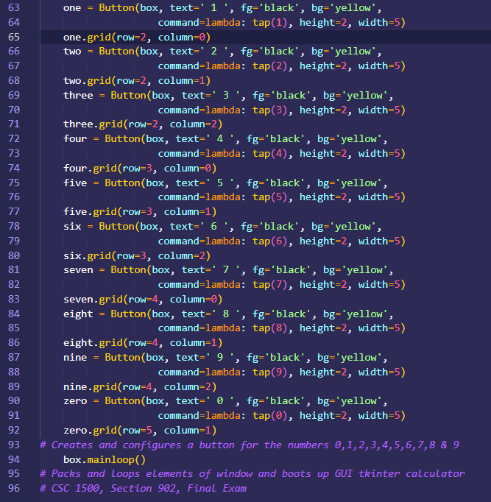

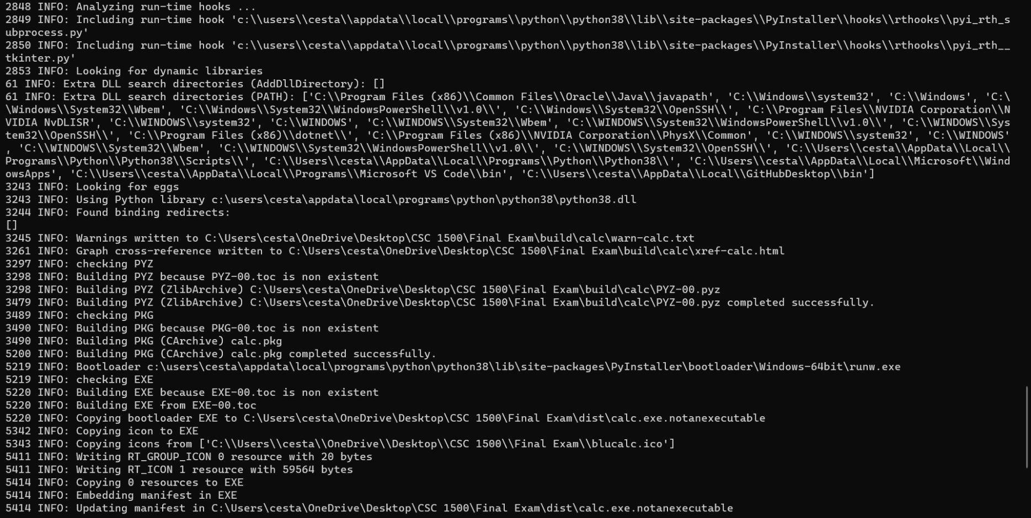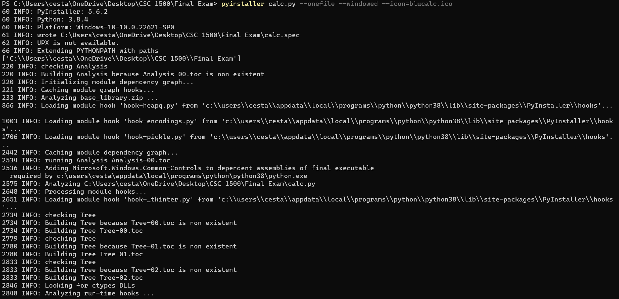

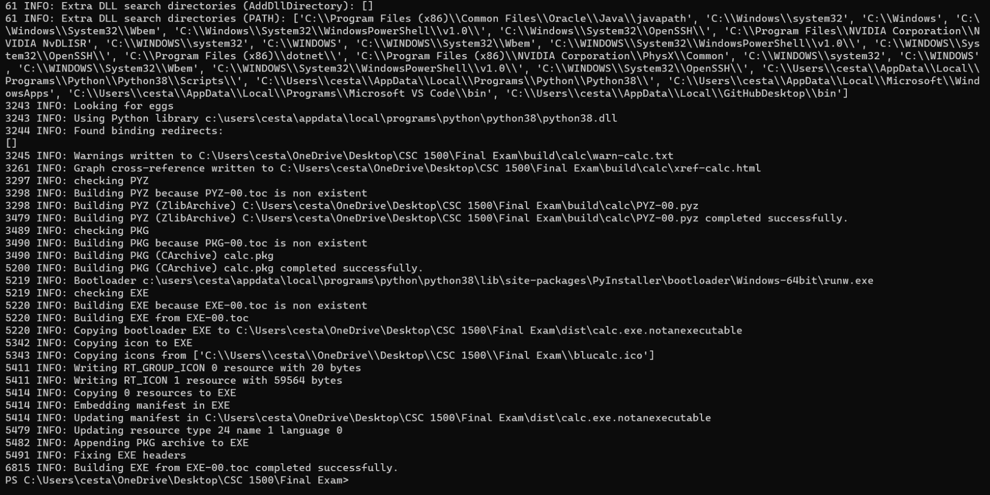

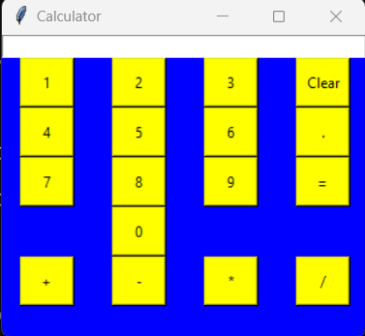**Display:**